Assignment – 1
Module–1(Fundamental)

Index

- What is SDLC?
- What is software testing?
- What is SRS?
- What is OOPS?
- Write Basic Concepts of OOPS
- What is object?
- What is class ?
- What is encapsulation ?
- What is inheritance ?
- What is polymorphism ?
- Draw Usecase on Online book shopping
- Draw Usecase on online bill payment system (paytm)
- Write SDLC phases with basic introduction
- Explain Phases of the waterfall model
- Write phases of spiral model
- Write agile manifesto principles
- Explain working methodology of agile model and also write pros and cons.
- Draw usecase on Online shopping product using COD.
- Draw usecase on Online shopping product using payment gateway.

1. What is SDLC?

- SDLC Known as System Development Life Cycle.
- It is structured process used to develop a quality project with efficiency.
- Lifecycle contains six stages Planning,Implementation,Testing, Documentation,Deployment,Maintenance & Support.

2. What is software testing?

- Software testing is process to identify correctness,completeness and quality of developed software.
- It is the phase where testers evealuate that whether software fulfill user's requirements or not.
- There are two types of Software testing:
i) Manual testing.
ii) Automation testing.

3. What is agile methodology?

- Agile is one of the SDLC model which is the most popular and working these days.
- Agile means ability to move quick and easy.
- It is combination of iterative & incremental SDLC model.
- Main purpose of this model is process adaptability and customer satisfaction by rapid delivery of working software product.
- Agile method break the whole product process into a small incremental parts which are provided in iteration.Each part of iteration simultaneously passing through the stages like Planning,Requirement gathering,Design,Coding,Unit testing and finally after each iteration working product is displayed to the customer.

4.What is SRS?

- SRS stands for Software requirement specification.
- Its a document that describe functionality of software and how that functionality will be performe to meet user's requirements.
- There are three types of requirements:
i) Customer requirement.
ii) Functional requirement
iii) Non-Functional requirement.

5.What is OOPS?

- OOPS stands for Object Oriented Programming System.
- Its programming method based on object which contains data in the form of fields.
- An object is called BLACK BOX in the form of testing.
- Details inside object are hidden.
- Everything in this world is an object
Example: A Car,A Pen etc...

6.Write basic concepts of OOPS?

- There are mainly six basic concepts of OOPS
1) Object
2) Class
3) Encapsulation
4) Inheritance
5) Polymorphism
6) Abstraction

7.What is Object?

- Object is an instance of class.we can create multiple object of any single class.
- Object contains properties and methods.
Real life example: I have a car, than car has a model,price,color which are known as proprty on other hand car can start, stop,drive these all are called methods/function of car.
- This is the basic unit of OOP(Object Oriented Programming).

8.What is Class?

- Class is a collection of Data members(Variables) and Member function(Methods,process) with its own behaviour.
- In other words we can say class provides blueprint to create objects.
- Real life example: A Car , car is a class and its model,price,engine,seat,start,stop these all are property,function and variables of car.

9.What is Encapsulation?

- It is the process of wrapping up data(properties) and behaviour(methods) of an object into a single unit(here unit is a class or interface).
- Data hiding is the main purpose of encapsulation.

10.What is Inheritance?

- Properties and behaviour of main class/parent class/base class derived(Inherit) by another sub class/child class/derived class is called inheritance.
- Main purpose of inheritance is reusability of code and extendibility of relation between the class.
- Mainly five types of inheritance are there:
1)Single inheritance.
2)Multilevel inheritance.
3)Hirarchical inheritance.
4)Multiple inheritance.(Java doesn't support directly)
5)Hybrid inheritance.(Java doesn't support directly)

11.What is Polymorphism?

- Poly refers to many and morphism refers to forms, so poly+morphism=Polymorphism means “Having many forms”.
- Ability to use one object in many forms called polymorphism.
- Real life example:
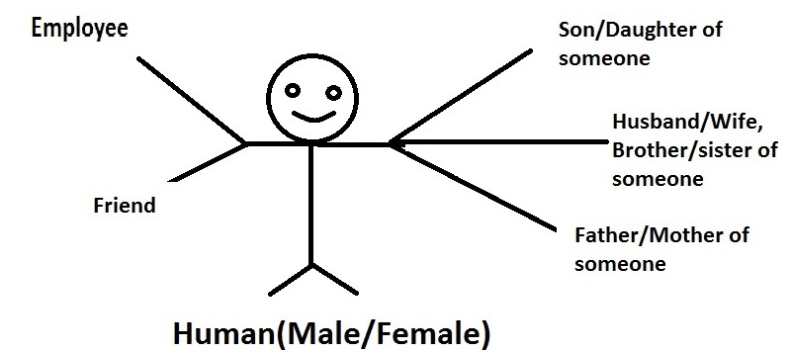
here in an example Human is one object who is standing in their life with the different forms.

12.Draw Usecase on Online book shopping.
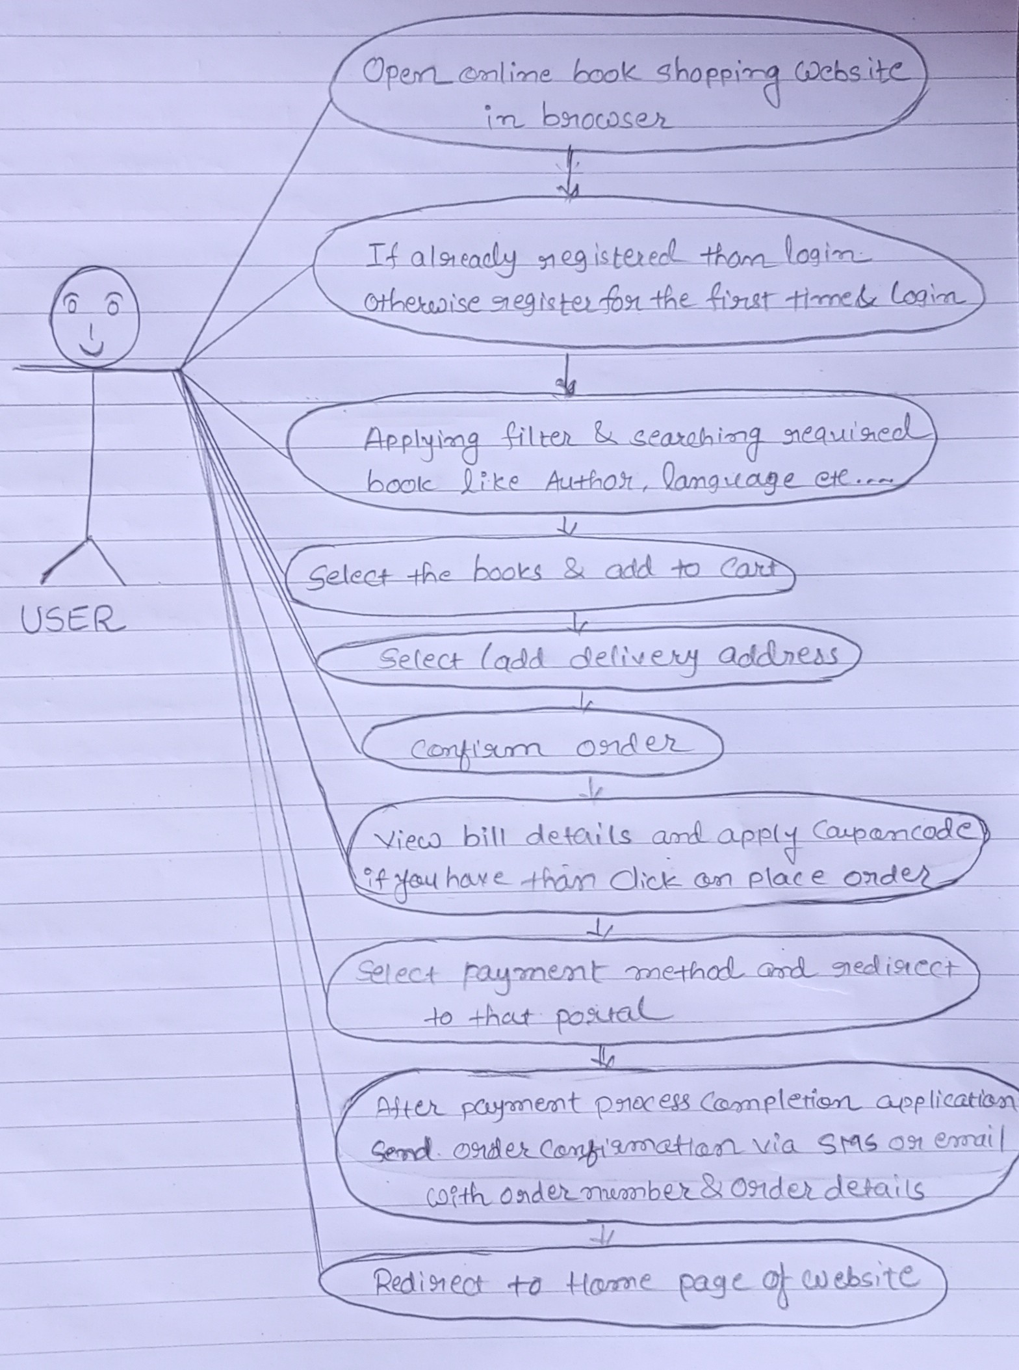

13.Draw Usecase on Online Bill payment system(Paytm).

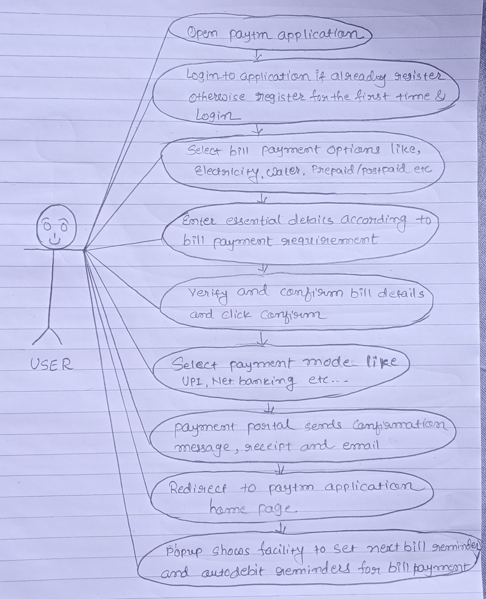

14.Write SDLC phases with basic introduction.

- There are six basic phases of SDLC.

1) Requirement Gathering/Collection

    - In this phase, developer needs to collect user's requirement to develop software. Requirement may be complete or incomplete and may be change in future as well. It is either in document or in written form.
    - Three types of problems can be arise during this stage
i) Lack of clearity.
ii) Requirement confusion.
iii) Requirement Amalgamation(coalesce,merge).
    - There are mainly two types of requirements
i) Functional Requirement.
ii) Non-Functional Requirement.

2) Analysis

    - In this phase developer needs to find all the business requirements from customer and than need to evaluate all the possibilities like budget,time span, and many other requirements of client.
    - For futher step developer should arrange work priority,
features of product, hardware and software compatability they required to develop any product.

3) Design

    - In this phase, Design team prepare document which explain actual planning,design,languageto be used to develop software,platform to be used in product.
    - Flow chart can be prepare to represent the working of software product.

4) Implementation/Development

    - This is the main phase where work start to develop any software.
    - Development team begin to code as per the work priority arrange in analysis phase.

5)Testing

    - Before publishing any project , Testing teem verify the system that satisfy all the requirement of user or not.
    - There are several types of testing perform by testing team like Performance testing,Unit testing,Functional testing,Security testing etc..

6) Maintenance

    - This is the final stage of SDLC.
    - In this phase user validate prepared system and finding the defacts which may missed during testing phase and than developer needs to fix that defacts.
    - In other words, Maintenance is the process of modifying a system after it has been deployed.
    - There are three types of maintenance:
i) Corrective Maintenance.
ii) Adaptive Maintenance.
Iii) Perfective Maintenance.

15.Explain phases of the waterfall model.

- Waterfall model is the basic SDLC model.
- It has six phases :

1)Requirement gathering

    - In this phase, developer needs to collect user's requirement to develop software. Requirement should be complete and can not change in future as well. It is either in document or in written form.

2) Analysis

      - In this phase developer needs to find all the business requirements from customer and than need to evaluate all the possibilities like budget,time span, and many other requirements of client.
      - For futher step developer should arrange work priority,
features of product, hardware and software compatability they required to develop any product.

3)Design

- After collecting all the requirements this phase begin where we have to create detail design document which explains the architecture ,user interface and components of system.

4) Implementation/Development

    - This is the main phase where work start to develop any software.
    - Development team begin to code as per the work priority arrange in analysis phase .
    - Unit testing perform to check and validate errors which can be resolve in every phase of code.

    - Testing

    - Before publishing any project , Testing teem verify the system that satisfy all the requirement of user or not.There are several types of testing perform by testing team like Performance testing,Unit testing,Functional testing,Security testing etc..

6) Maintenance

    - This is the final stage of any SDLC model.
    - In this phase user validate prepared system and finding the defacts which may missed during testing phase and than developer needs to fix that defacts.
    - In other words, Maintenance is the process of modifying a system after it has been deployed.

16.Write phases of spiral model.

- There are mainly four stages of spiral model.
i) Planning.
ii) Risk analysis.
Iii) Engineering/Product development.
iv) Customer evaluation/Next phase planning.

17.Write agile manifesto principles

- There are mainly four agile manifesto principles.
i) Individual interaction.
ii) Customer collaboration.
iii) Working software.
iv) Responding to change.

18. Explain working methodology of agile model and also write pros and cons.

- Agile is one of the SDLC model which is the most popular and working these days.
- Agile means ability to move quick and easy.
- It is combination of iterative & incremental SDLC model.
- Main purpose of this model is process adaptability and customer satisfaction by rapid delivery of working software product.
Agile method break the whole product process into a small incremental parts which are provided in iteration.Each part of iteration simultaneously passing through the stages like Planning,Requirement gathering,Design,Coding,Unit testing and finally after each iteration working product is displayed to the customer.

ADVANTAGES | DISADVANTAGES
Continuously developers connected with client so transperancy can be maintain. | Time duration is not fix hence budget may exhausted.
Requirements can be add and remove at any stage of development. | Lack of proper documentation.
Can develop clear and accurate software on time. | Not suitable to handle complex dependencies.
Face to face communication makes better product. | Totally relay on customer, so if customer has not clear ideas than it may distract to the developer as well.
Pramote team work and cross training. | Transfer technology to new tem member is quite difficult due to lack of documentation.
No planning phase required.We can move in any phase of SDLC at any phase of developing.

19. Draw usecase on online shopping product using COD.

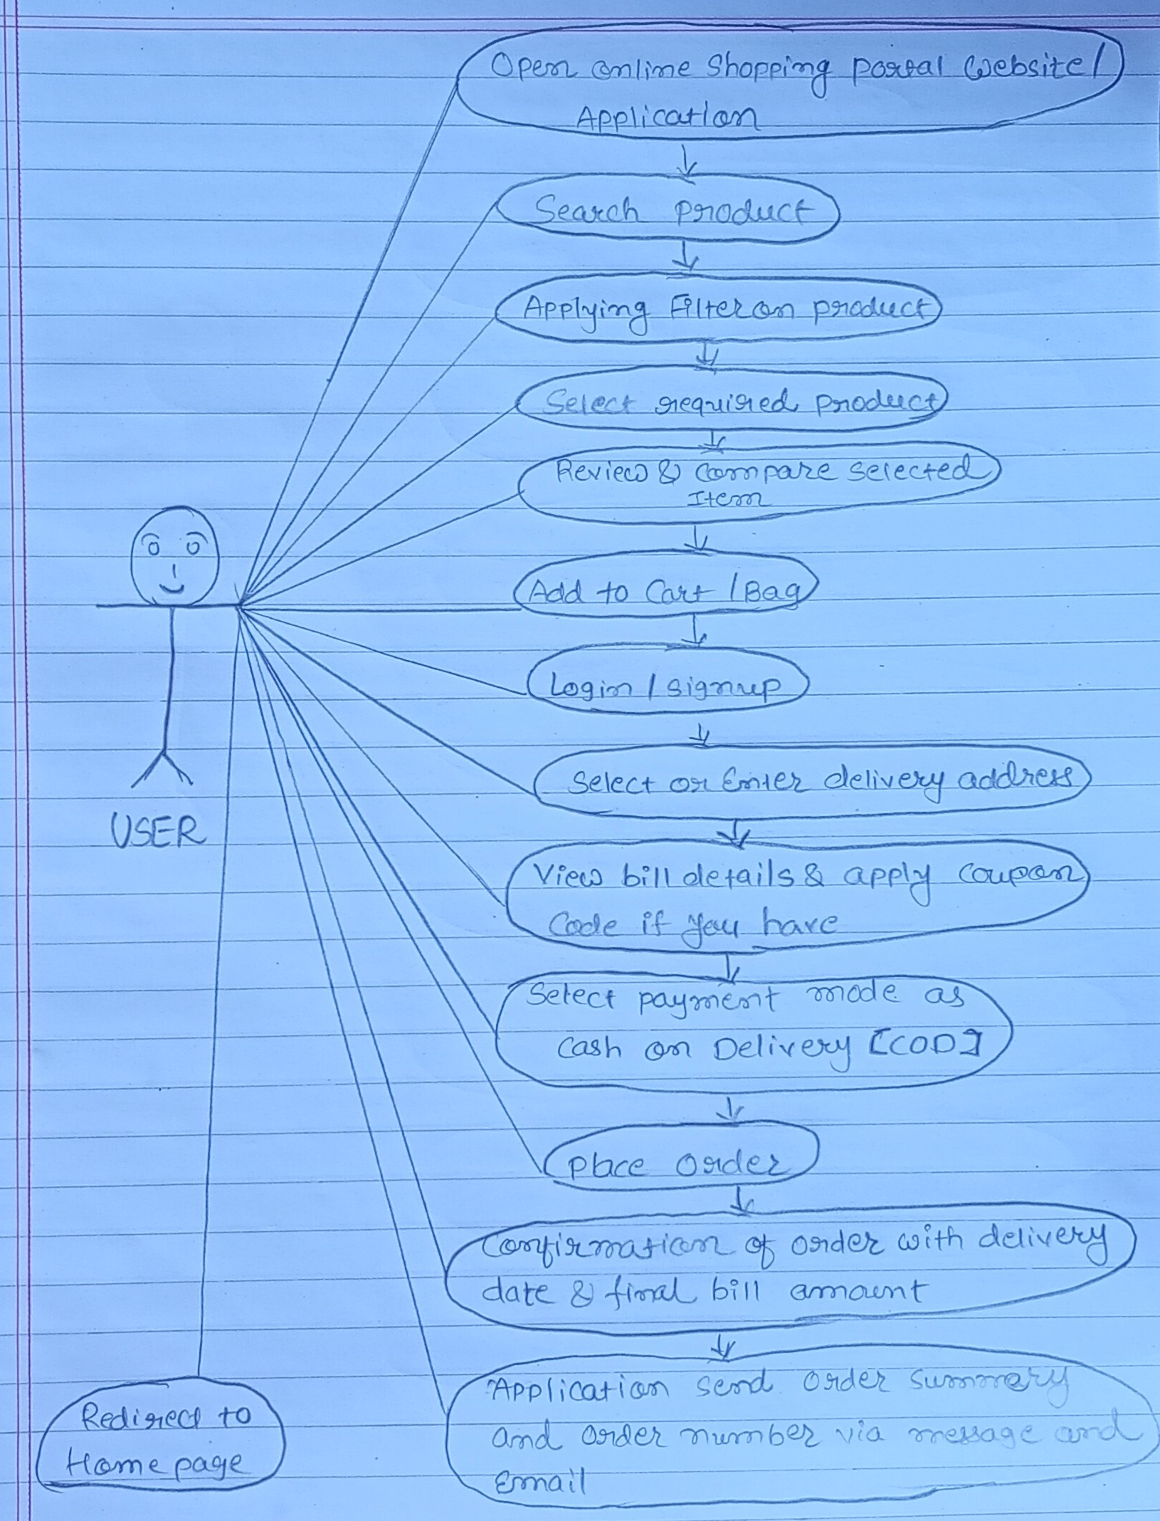

20. Draw usecase on online shopping product using payment gateway.

